MAP TO REACH
SANT ANGELO LE FRATTE
WITH THE BUS:
http://www.autolineelamanna.it/20190502/napoli.html
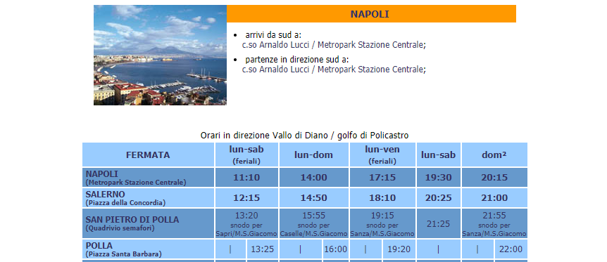
WITH THE TRAIN
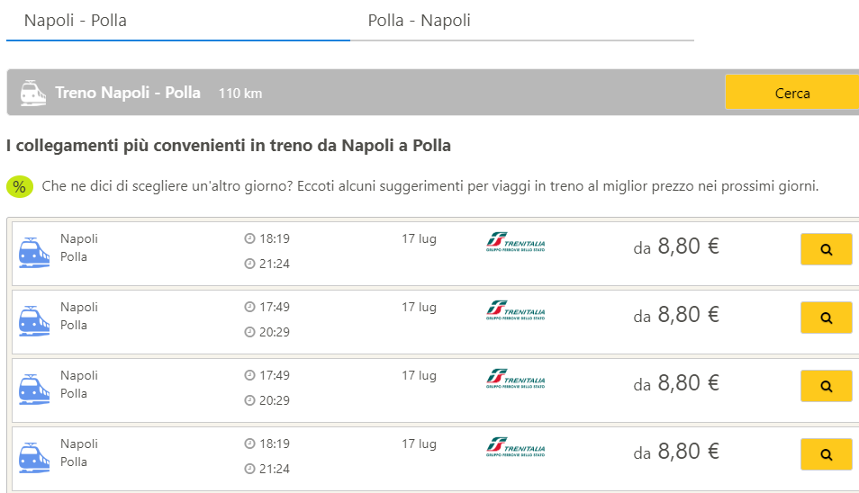
Final destination: municypal gym of St Angelo Le Fratte, Via Guglielmo Marconi

